

A Project Report On

**Tourism Guide System**

**By**

## Santosh Kumar P B.TECH

### Batch: 2020 – 5082

**Center:** Banglore-TC Palya

Under the Guidance of,

**Jayant V.**

**Technical Trainer**

**EduBridge**

(School of coding)

**Introduction:**

This Project **Tourism Guide System** has been developed on **Java, Servlet, JSP and MySQL**. The main purpose for developing this project is to provide Tourism Guide for Travelers. This project intends different types of forms which provides an basic information about tourism across the world through online. In this **Tourism Guide System project in java** provides Customers an travelling feel with lots of information . This project provides a lots of features to manage in very well manner.

Software Requirements:

**Front end:** Java/J2EE technologies (Servlet, JSP), HTML,

CSS, Bootstrap, JDBC.

**Back end:** MySQL.

**Server:** Apache Tomcat v8.0V

**IDE:** Eclipse IDE for Java EE Developers

**Browser:** Best result on Google Chrome / Opera Mini

**Operating System:**  Window 7 / 8 / 10.

**Data Dictionary:**

**DataBase:**

create database tourist_guide_system; use tourist_guide_system;

* **Admin**:  **( Table name: `tbladmin`)**

**1.) Create Table with name `tbladmin`.**

CREATE TABLE `tbladmin`

(

`id` bigint NOT NULL AUTO_INCREMENT,

`uname` varchar(100) NOT NULL,

`password` varchar(100) DEFAULT NULL,

`email` varchar(100) DEFAULT NULL,

`created_at` timestamp NULL DEFAULT CURRENT_TIMESTAMP,

updated_at` datetime DEFAULT CURRENT_TIMESTAMP ON UPDATE CURRENT_TIMESTAMP,

PRIMARY KEY (`id`)

)

ENGINE=InnoDB AUTO_INCREMENT=2 DEFAULT CHARSET=utf8mb4;

**2.) Insert Values into `tbladmin`.**

INSERT INTO `tbladmin` VALUES

(

[10, 'admin123', '123456', 'kadamk33@gmail.com',](mailto:10,'admin123','123456','kadamk33@gmail.com',)

'2021-01-27 04:41:05', '2021-01-28 11:53:17'

);

* **Captcha**:  **( Table name: `tblcaptcha`)**

**1.) Create Table with name `tblcaptcha`.**

CREATE TABLE `tblcaptcha`

(

`captcha` varchar(100) DEFAULT NULL

)

ENGINE=InnoDB DEFAULT CHARSET=utf8mb4;

**2.) Insert Values into `tbladmin`.**

INSERT INTO `tblcaptcha` VALUES ('16358');

* **Contact**:  **( Table name: `tblcontact`)**

1. **) Create Table with name `tblcontact`**

CREATE TABLE `tblcontact`

(

`contact_id` int NOT NULL AUTO_INCREMENT,

`name` varchar(200) DEFAULT NULL,

`email` varchar(100) DEFAULT NULL,

`phone` varchar(200) DEFAULT NULL,

`message` varchar(500) DEFAULT NULL,

`created_at` timestamp NULL DEFAULT CURRENT_TIMESTAMP,

PRIMARY KEY (`contact_id`)

)

ENGINE=InnoDB AUTO_INCREMENT=2 DEFAULT CHARSET=utf8mb4;

**2.) Insert Values into `tblcontact`.**

INSERT INTO `tblcontact` VALUES

(

1,

'Kishor Balasah Kadam',

['kadamk33@gmail.com',](mailto:'kadamk33@gmail.com',)

'+917276763516',

'Awesome tourist website.',

'2021-01-26 12:51:49'

);

* **Feedback**:  **( Table name: `tblfeedback`)**

**1.) Create Table with name `tblfeedback`.**

CREATE TABLE `tblfeedback`

(

`fid` varchar(100) NOT NULL,

`feedback` varchar(500) DEFAULT NULL,

`uname` varchar(100) DEFAULT NULL,

`created_at` timestamp NOT NULL DEFAULT CURRENT_TIMESTAMP,

PRIMARY KEY (`fid`)

)

ENGINE=InnoDB DEFAULT CHARSET=utf8mb4;

**2.) Insert Values into `tblfeedback`.**

INSERT INTO `tblfeedback` VALUES

( 'F20210127063614','Awesome tourist website.','kishor','2021-01-27 13:06:30' ),

( 'F20210127071944','Nice tourist portal.','arun','2021-01-27 13:49:58' ),

( F20210127072340','Its an awesome and easy to handle tourism website.', 'sagar','2021-01-27 13:53:55' );

* **Places**:  **( Table name: `tblplaces`)**

**1.) Create Table with name `tblplaces`**

CREATE TABLE `tblplaces`

(

`place_id` varchar(100) NOT NULL,

`place_name` varchar(100) DEFAULT NULL,

`image_name` varchar(200) DEFAULT NULL,

`place_image_path` varchar(400) DEFAULT NULL,

`place_address` varchar(100) DEFAULT NULL,

`place_area` varchar(100) NOT NULL,

`place_tags` varchar(100) DEFAULT NULL,

`place_description` varchar(100) DEFAULT NULL,

`created_at` timestamp NULL DEFAULT CURRENT_TIMESTAMP,

`updated_at` datetime DEFAULT CURRENT_TIMESTAMP ON UPDATE

CURRENT_TIMESTAMP,

PRIMARY KEY (`place_id`)

)

ENGINE=InnoDB DEFAULT CHARSET=utf8mb4;

**2.) Insert Values into `tblplaces`.**

INSERT INTO `tblplaces` VALUES

( 'T20210127042048','Mahabaleshwar','mahabaleshwar.jpg','F:/project-workspace/TouristGuideSystem/WebContent/upload/mahabaleshwar.jpg','Satara, Maharashtra','Hill Station','#cold','Its a hill station, cool nature, Maharashtra popular tourist place.','2021-01-27 10:51:22','2021-01-28 16:43:32' ),

( 'T20210127042220','Kerala','kerala.jpg','F:/project-workspace/TouristGuideSystem/WebContent/upload/kerala.jpg','Kerala','Hill Station','#touristplace','Its a cool nature, popular tourist place.','2021-01-27 10:53:43','2021-01-28 16:44:03' ),

( 'T20210128045047','Goa','goa.jpg','F:/project-workspace/TouristGuideSystem/WebContent/upload/goa.jpg','Panaji, Goa.','Sea Area','#sea','Its an beach area.','2021-01-28 11:21:33','2021-01-28 16:51:33' );

* **Questions**:  **( Table name: `tblquestion`)**

**1.) Create Table with name `tblquestion`.**

CREATE TABLE `tblquestion`

(

`question_id` int NOT NULL AUTO_INCREMENT,

`question_name` varchar(100) DEFAULT NULL,

PRIMARY KEY (`question_id`)

)

ENGINE=InnoDB AUTO_INCREMENT=107 DEFAULT CHARSET=utf8mb4;

**2.) Insert Values into `tblquestion`.**

INSERT INTO `tblquestion` VALUES

( 101, 'Would you like to go to the beach?' ),

( 102, 'Would you like to visit Hill Station? '),

( 103, 'Would you like to have landscape view? '),

( 104, 'Would you like to visit Museum?' ),

( 105, 'Would you like to visit Temple?' ),

( 106, 'Would you like to visit Fort?' );

* **Users**:  **( Table name: `tbluser`)**

**1.) Create Table with name `tbluser`.**

CREATE TABLE `tbluser`

(

`user_id` varchar(100) NOT NULL,

`user_full_name` varchar(200) DEFAULT NULL,

`user_email` varchar(100) DEFAULT NULL,

`user_mobile` varchar(100) DEFAULT NULL,

`user_address` varchar(100) DEFAULT NULL,

`uname` varchar(100) NOT NULL,

`upass` varchar(100) DEFAULT NULL,

`created_at` timestamp NULL DEFAULT CURRENT_TIMESTAMP,

`updated_at` datetime DEFAULT CURRENT_TIMESTAMP ON UPDATE CURRENT_TIMESTAMP,

PRIMARY KEY (`user_id`)

)

ENGINE=InnoDB DEFAULT CHARSET=utf8mb4;

**2.) Insert Values into `tbluser`.**

INSERT INTO `tbluser` VALUES

( 'U20210218111209', 'Kishor [Kadam', 'kadamk33@gmail.com',](mailto:Kadam','kadamk33@gmail.com',) '+917276763516','Bhalawani, Ahmednagar, Maharashtra.','kishor', 'eMRXJqfQHxUWdejWk5Y1wg==','2021-02-18 05:42:47','2021-02-18 11:12:47' ),

( ['U20210218111258','Javed Tamboli','javed.tamboli@gmail.com','8369651475',](mailto:'U20210218111258','JavedTamboli','javed.tamboli@gmail.com','8369651475',) 'Charoli, Pune.','javed','eMRXJqfQHxUWdejWk5Y1wg==','2021-02-18 05:44:04','2021-02-18 11:14:04' ),

( ['U20210219094358', 'Sagar Kharmale', 'sagarkharmale@gmail.com','8456571542',](mailto:'U20210219094358','SagarKharmale','sagarkharmale@gmail.com','8456571542',) 'Bhandgaon, Ahmednagar, Maharashtra.','sagar','WKtTP+d151cGfskREhKuJA==', '2021-02-19 16:15:27','2021-02-19 21:45:27' );

* **User Question & Answer**:  **( Table name:**

**`tbluserquestionanswer`)**

1. **) Create Table with name `tbluserquestionanswer``.**

CREATE TABLE `tbluserquestionanswer`

(

`user_id` varchar(100) DEFAULT NULL,

`question_id` int DEFAULT NULL,

`answer` varchar(100) DEFAULT NULL

)

ENGINE=InnoDB DEFAULT CHARSET=utf8mb4;

**2.) Insert Values into `tbluserquestionanswer``.**

INSERT INTO `tbluserquestionanswer` VALUES

( 'U20210218111209',101,'No' ), ( 'U20210218111209',102,'No'), ('U20210218111209',103,'Yes'), ('U20210218111209',104,'Yes'), ('U20210218111209',105,'Yes'), ('U20210218111209',106,'Yes'), ('U20210218111258',101,'No'), ('U20210218111258',102,'Yes'), ('U20210218111258',103,'Yes'), ('U20210218111258',104,'No'), ('U20210218111258',105,'No'), ('U20210218111258',106,'Yes'), ('U20210219094358',101,'Yes'), ('U20210219094358',102,'No'), ('U20210219094358',103,'Yes'), ('U20210219094358',104,'Yes'), ('U20210219094358',105,'No'), ('U20210219094358',106,'Yes');

# Description and Modules of “TOURISM MANAGEMENT SYSTEM” Project :

## **Description** :

Fgfgfgfgfgfg

Gfg

Fgf

Fgfg

Fgfgfgd

Gffdgf

Gfg

Fg

Fgfg

fdgfgf

## Main Page Modules **/** Menu Columns :

## Main Module’s:

1. **Admin Login**
2. **User Register**
3. **User Login**
4. **About**
5. **Contact**
6. **Gallery**

**Sub module’s:**

1. **Destination**
2. **Know India**
3. **Wish List**

*Main Home Page Images.*





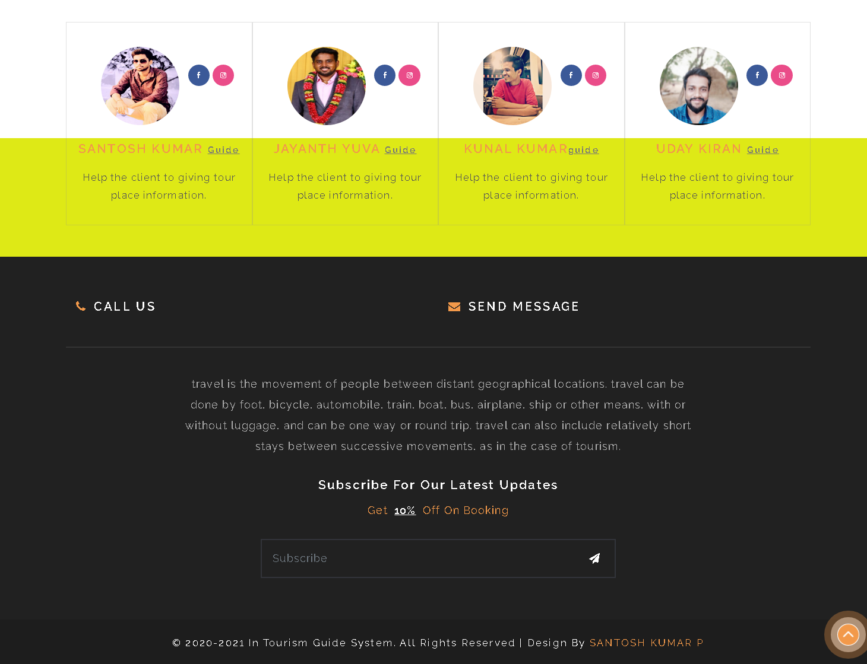

*About Us Page.*



*Contact Page.*

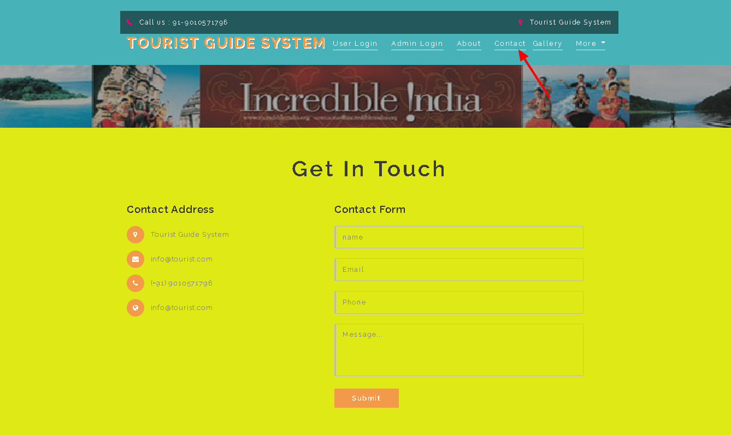

*Gallery Page.*

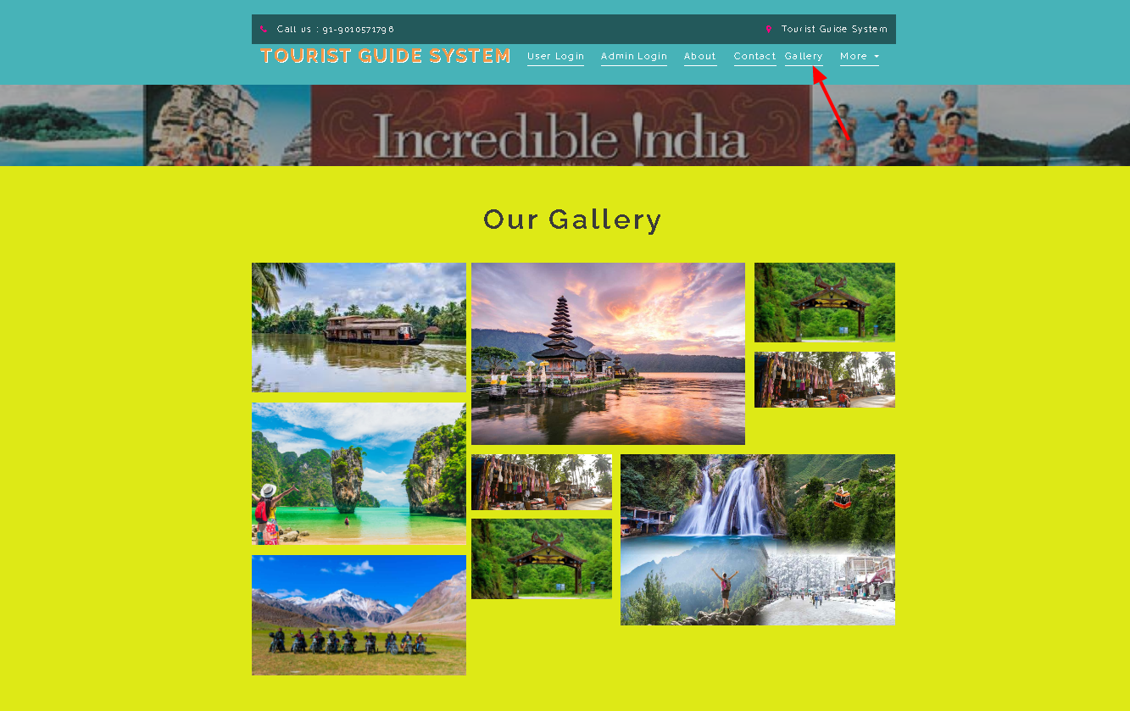

*Destination’s Column Page.*

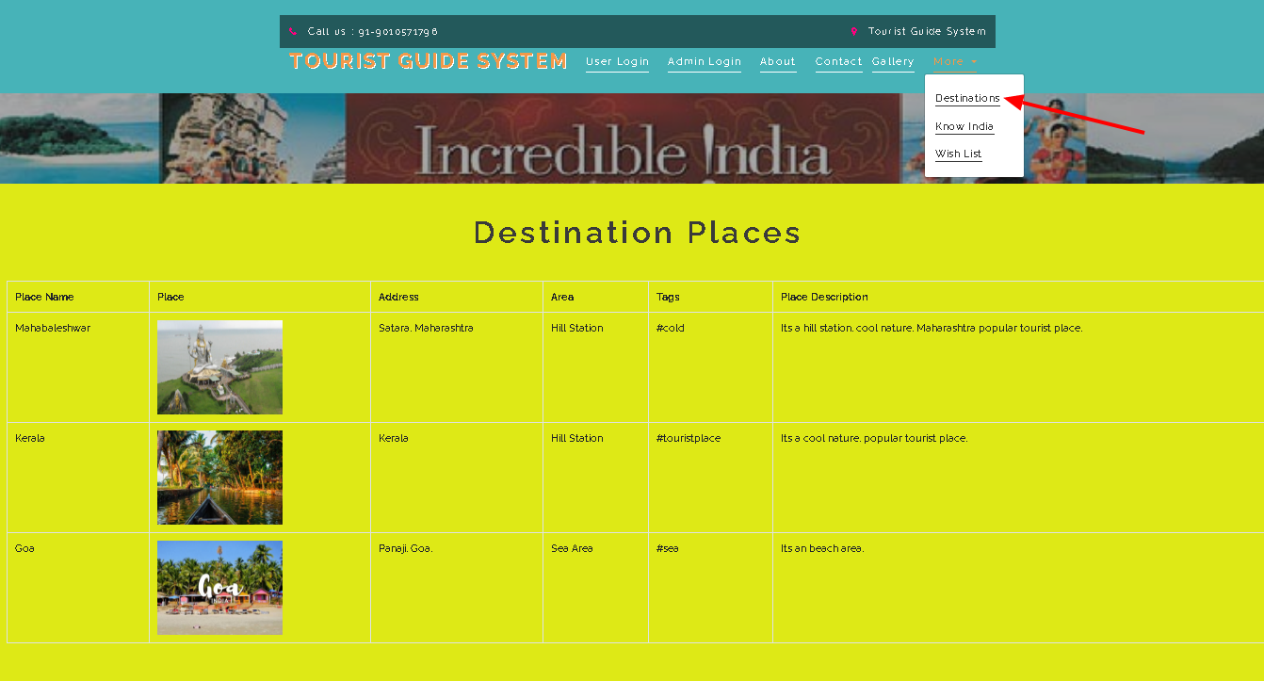

*Know India Page.*



# Modules /Columns of User Profile in “TOURISM MANAGEMENT SYSTEM” Project :

## Main Module’s:

1. **User Registration**
2. **User Login**
3. **User Dashboard Page.**
4. **Search Tourist Places**
5. **Map View.**
6. **Your Feedback.**

* **Sub module’s:**

1. **My Profile.**
2. **Update Profile.**
3. **Change Password.**

*User Registration Page.*

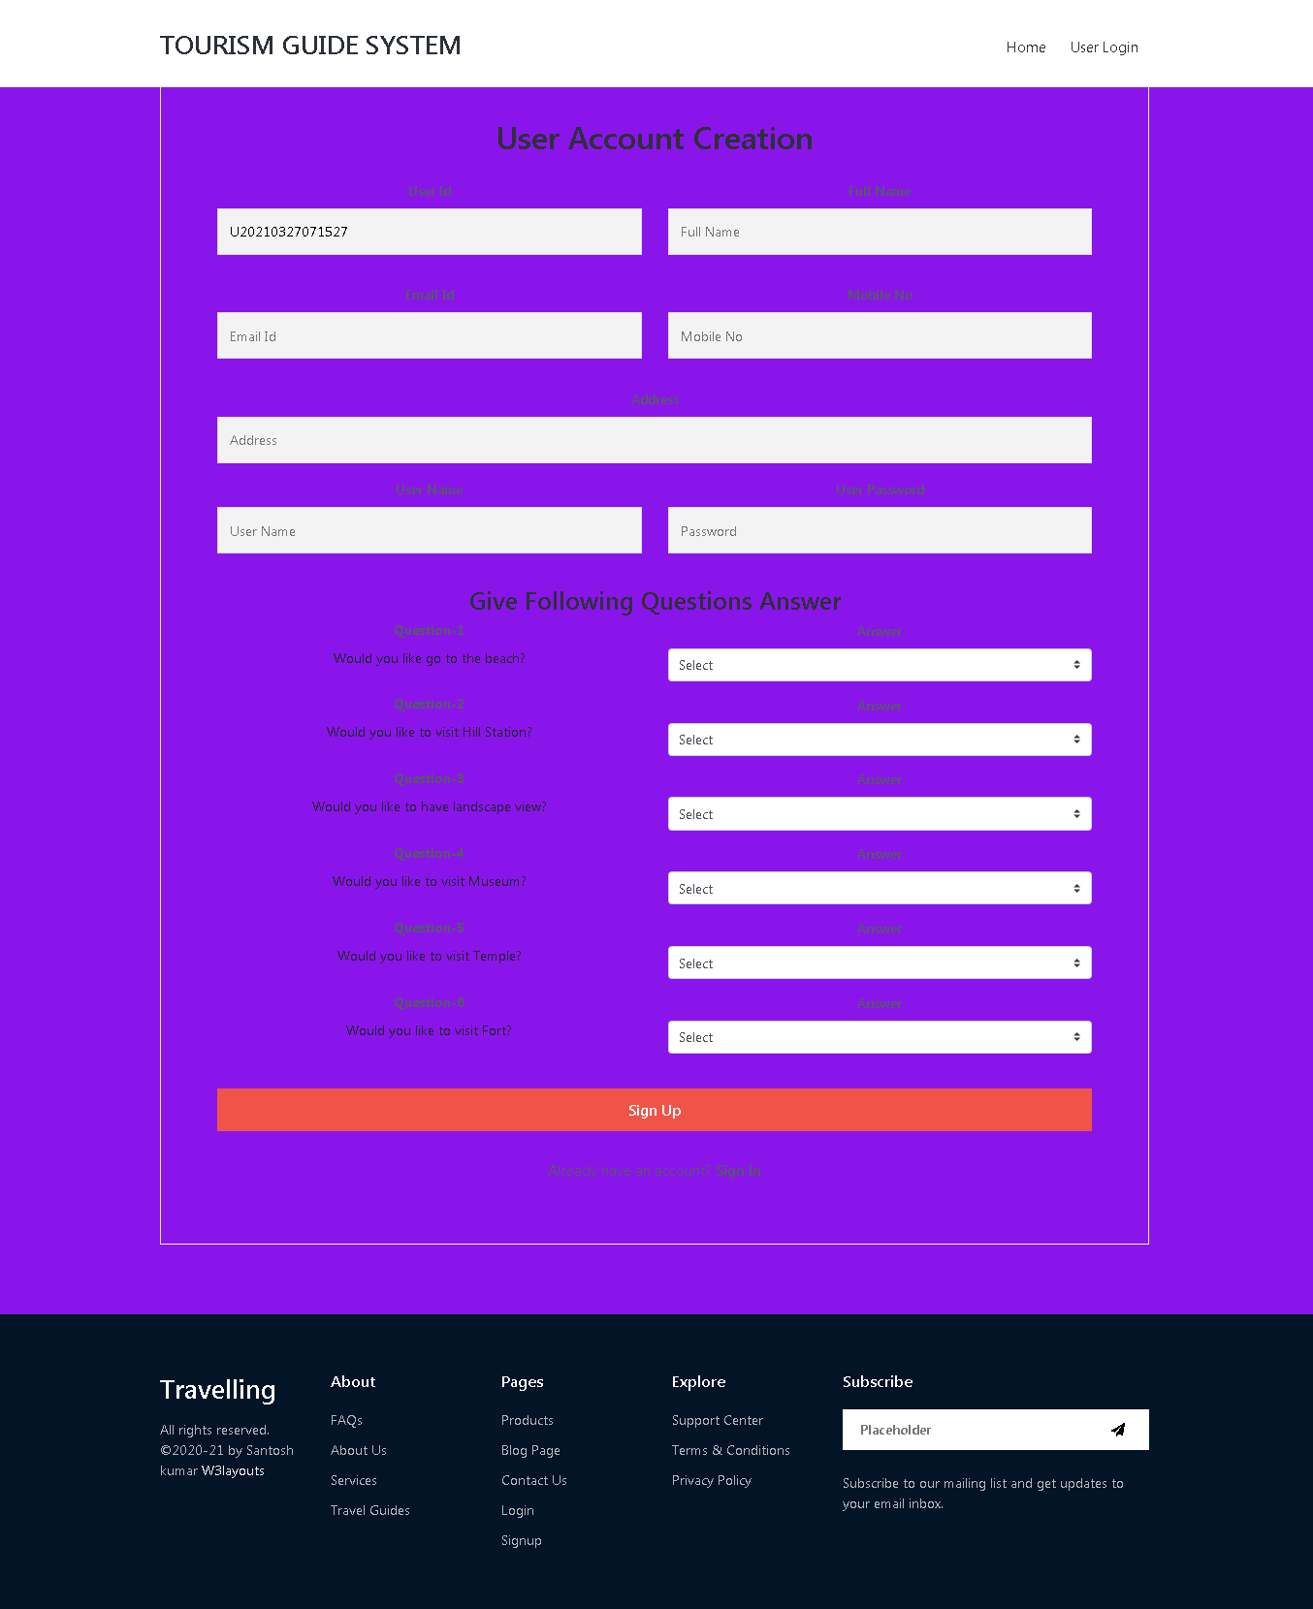

*User Login Page.*

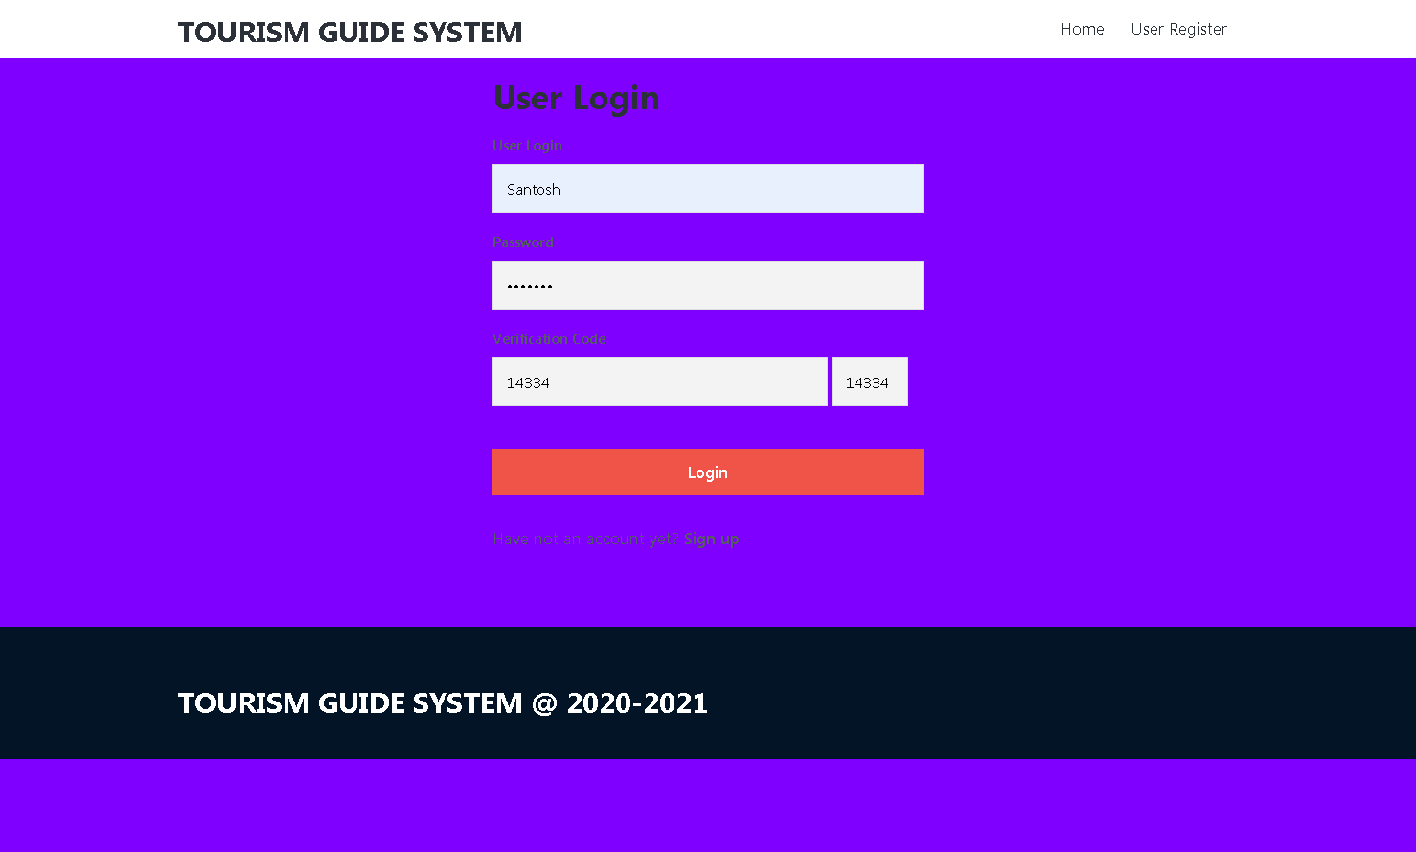

*User Dashboard Page.*

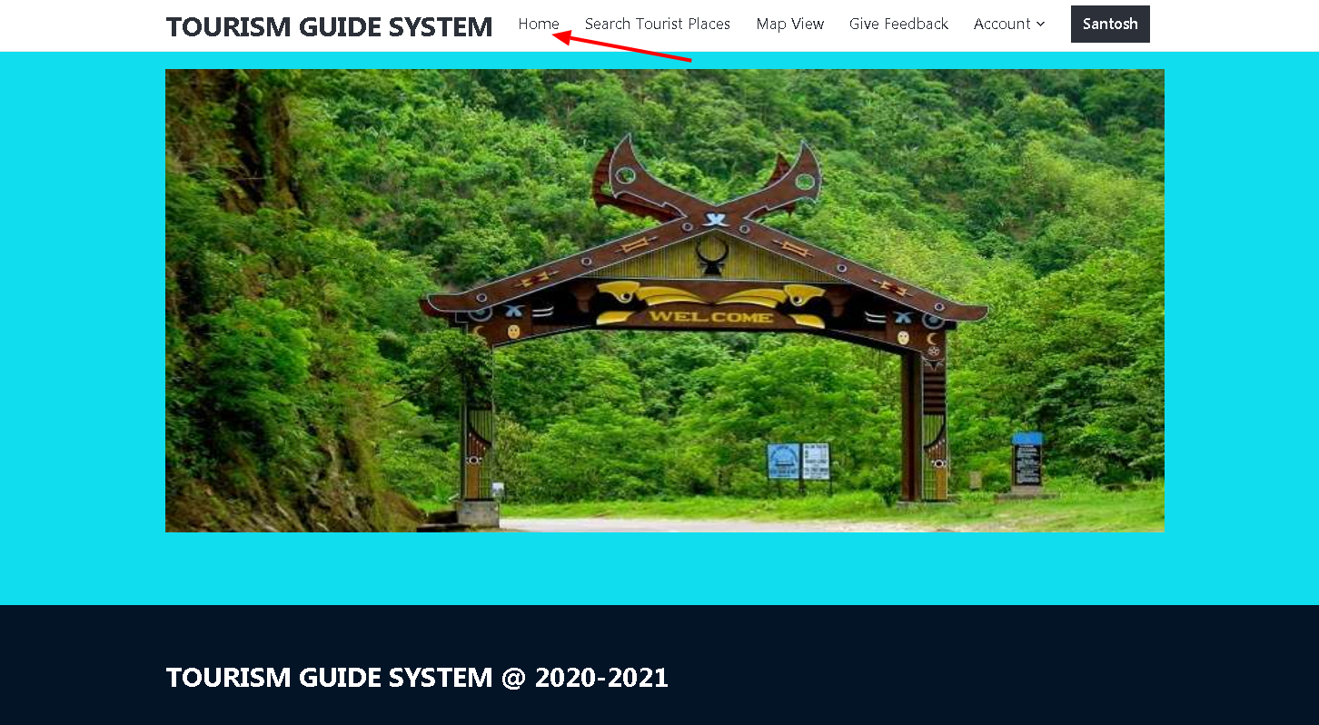

*Search Tourist Places. ( USER )*

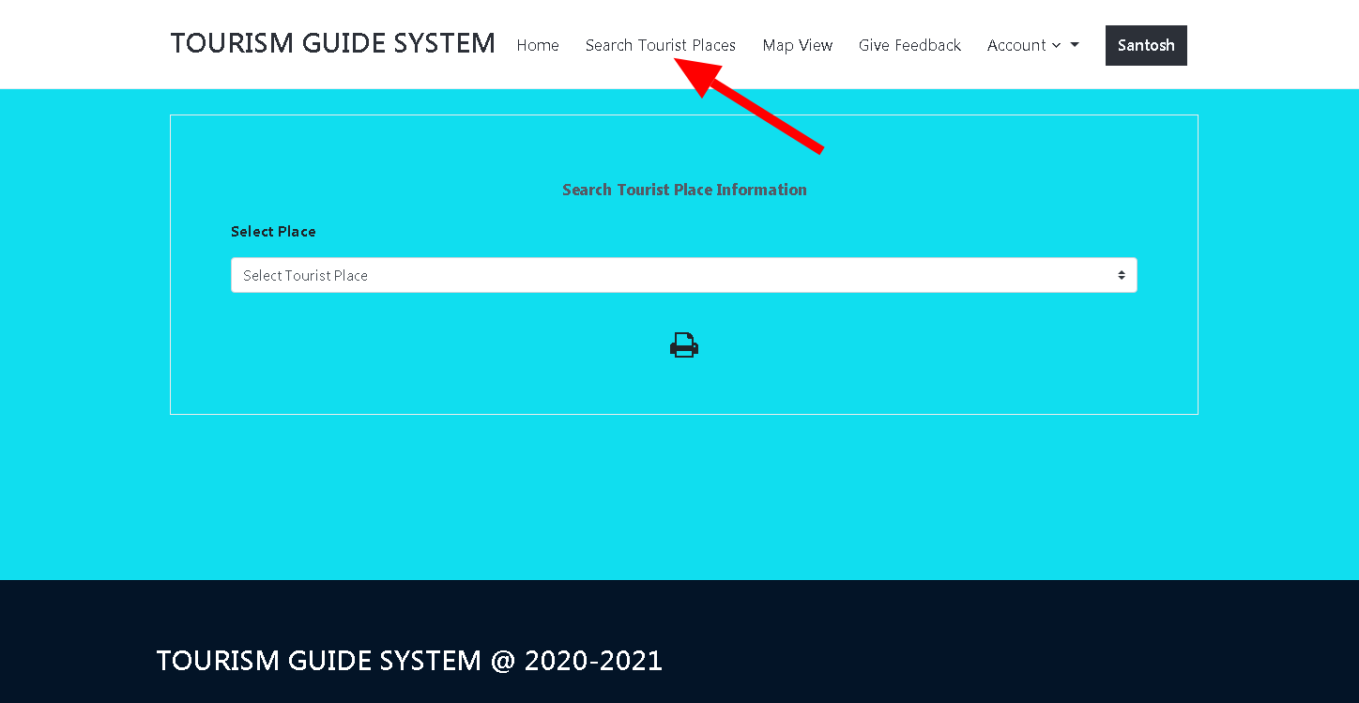

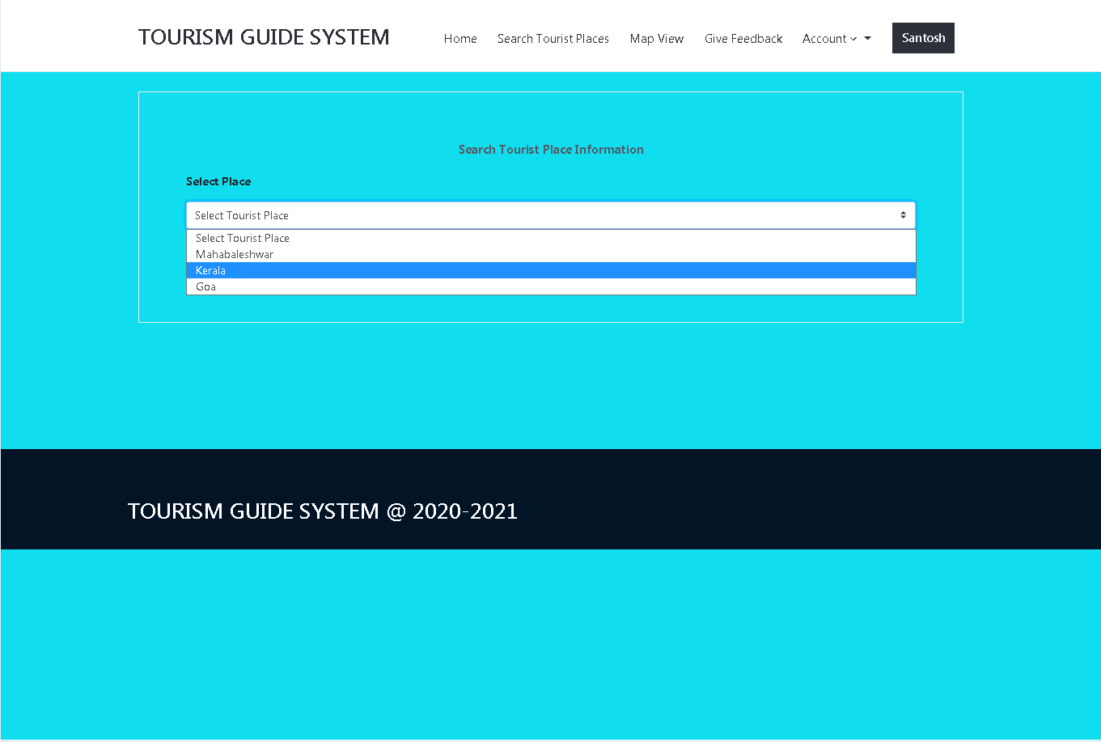

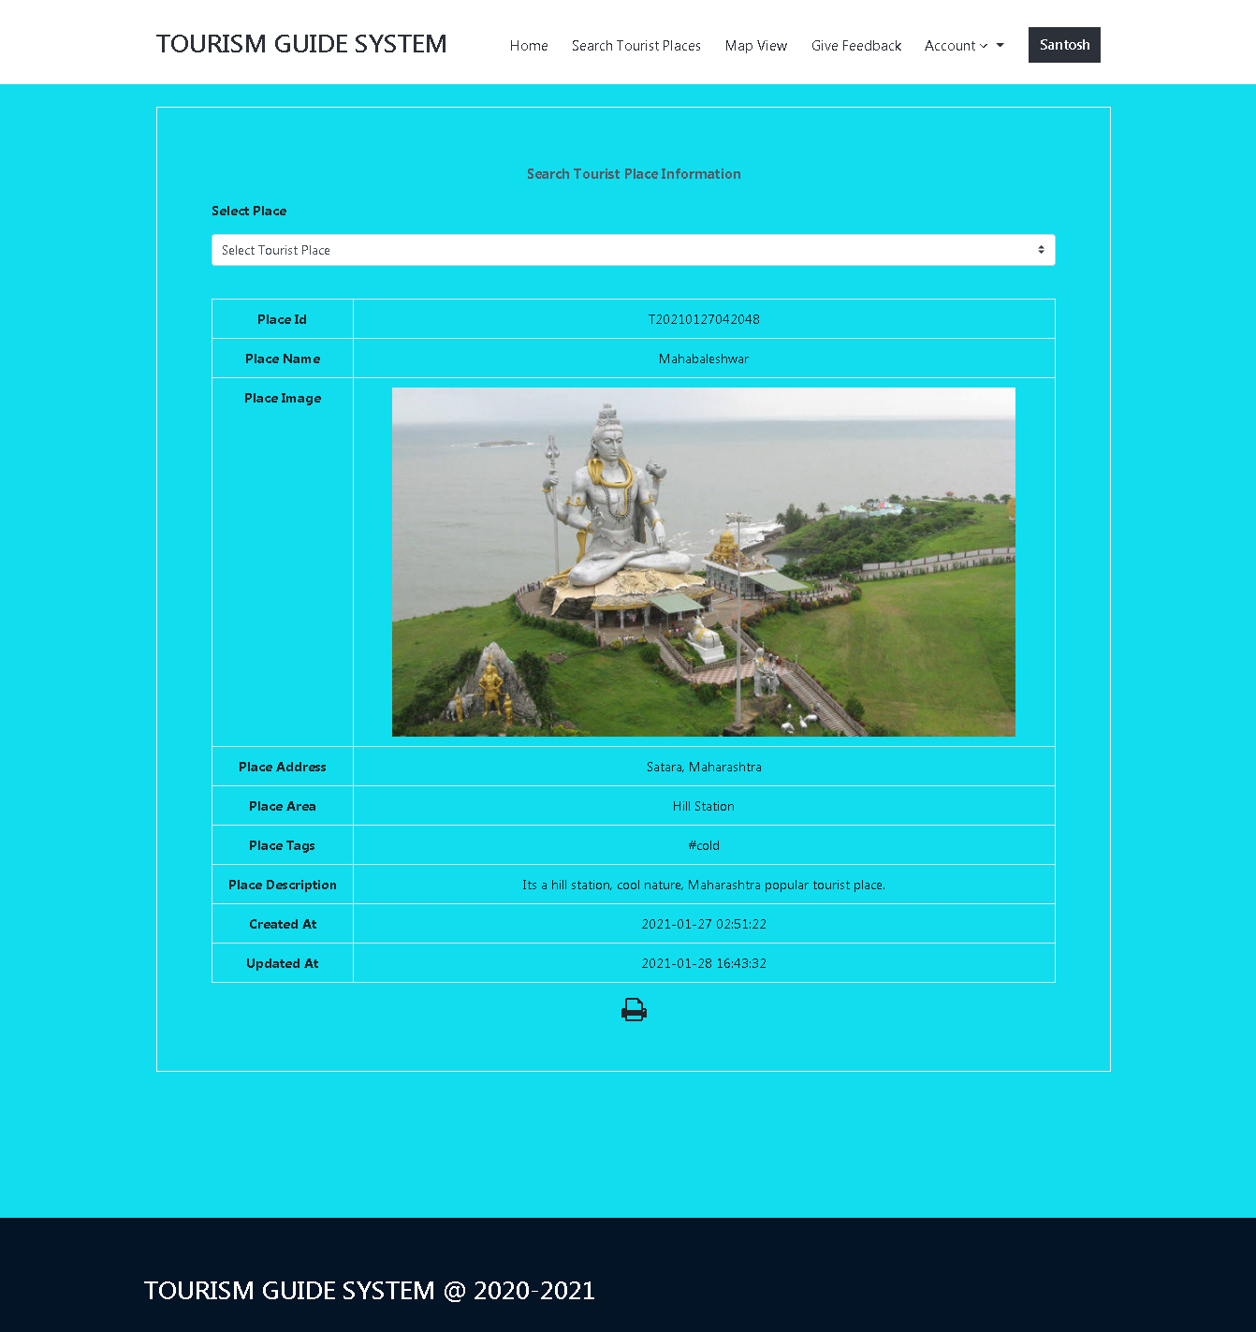

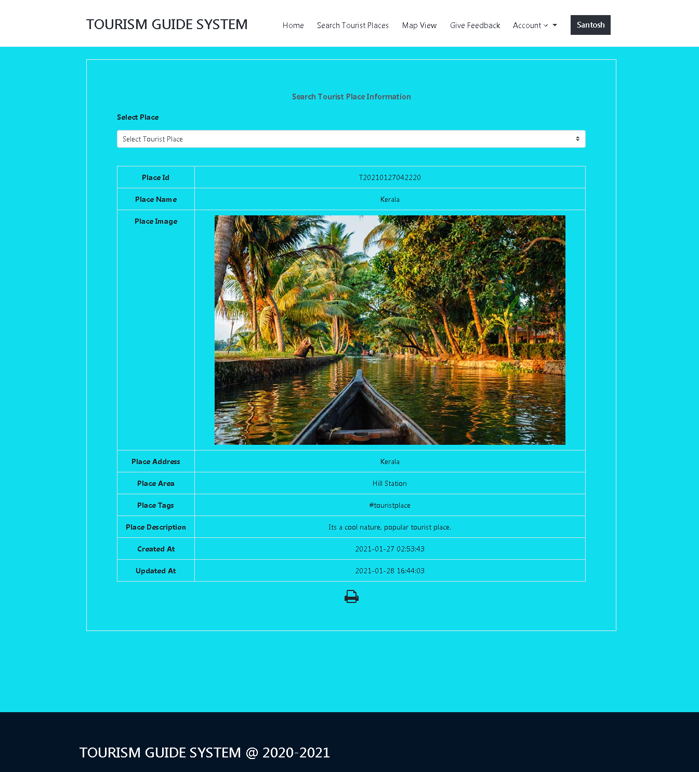

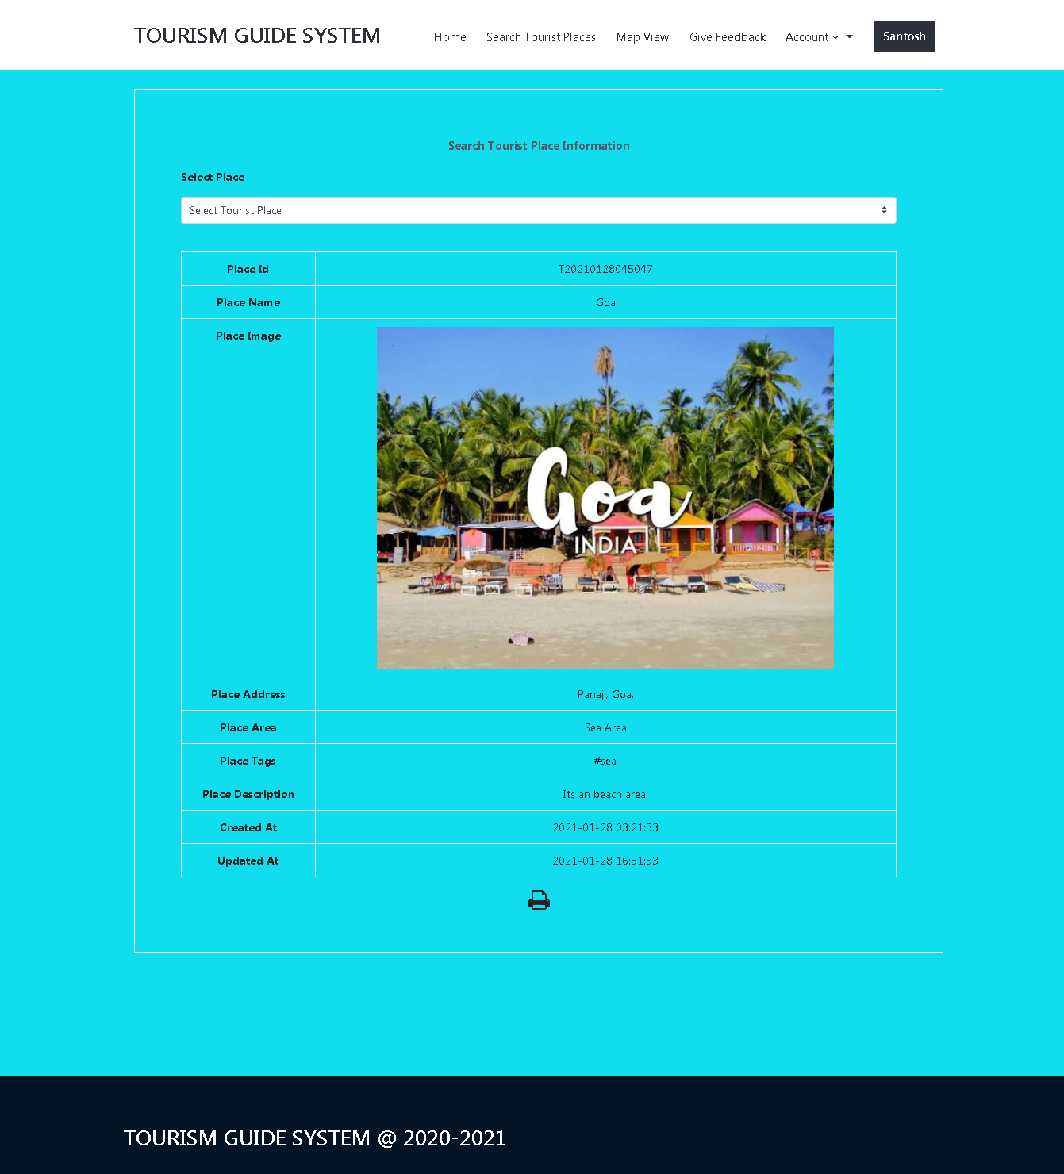

*Map View. ( USER )*

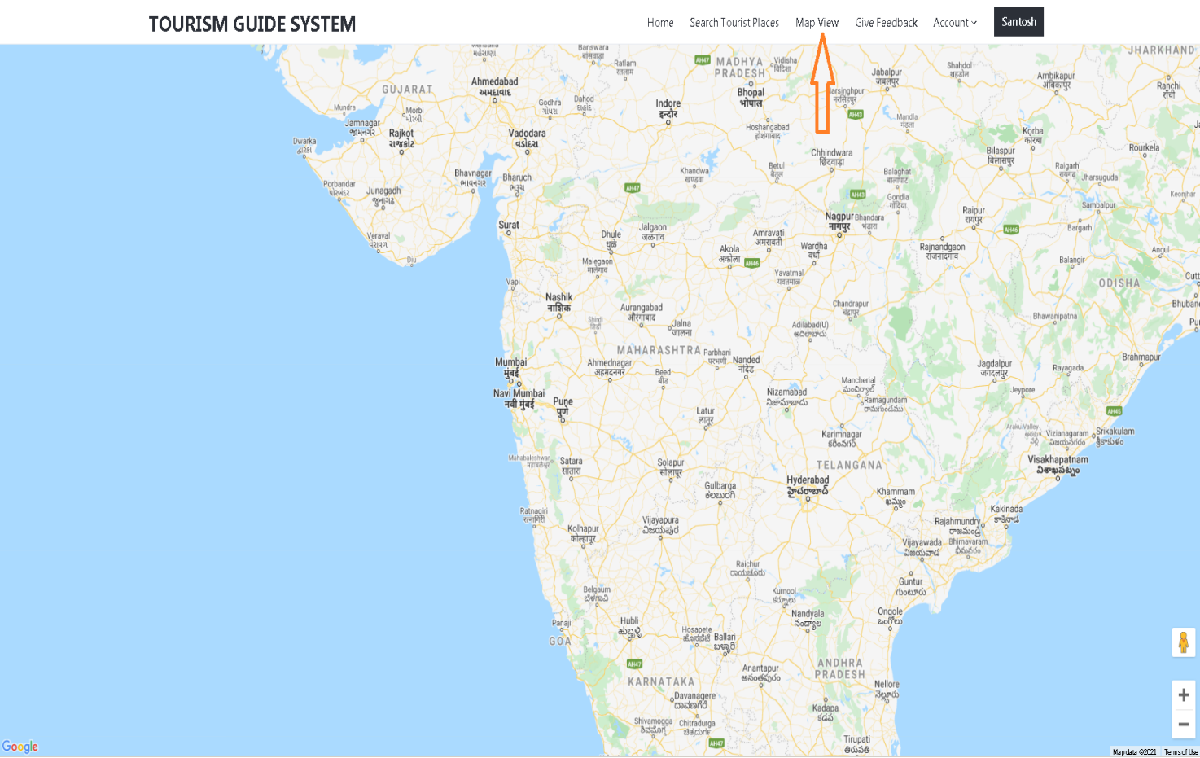

*Your Feedback. ( USER )*

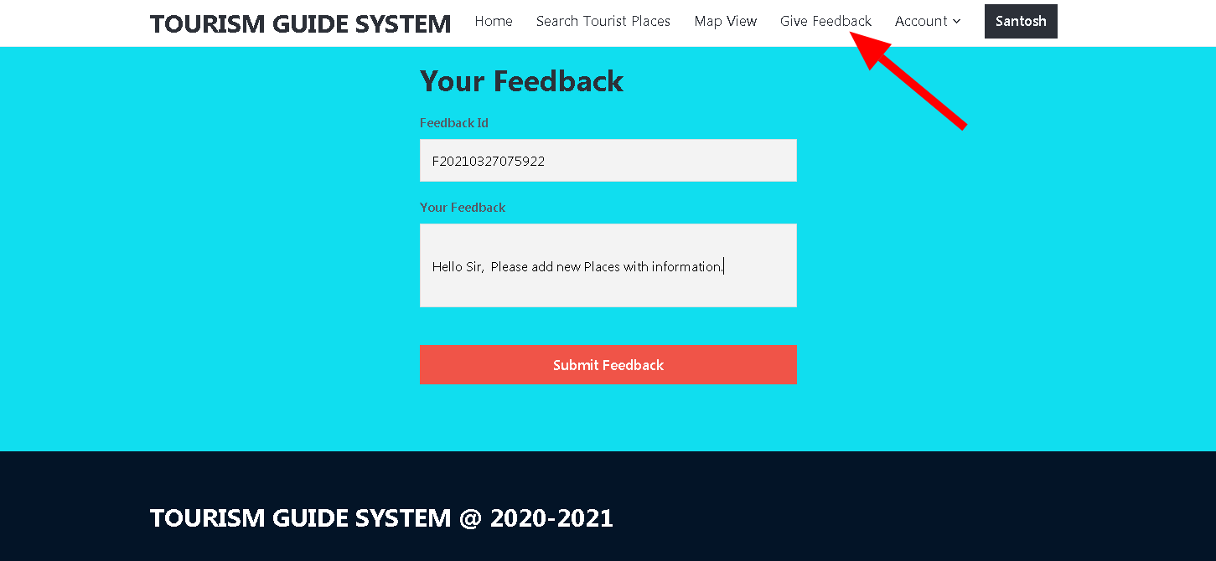

*Sub Column's. ( USER )*

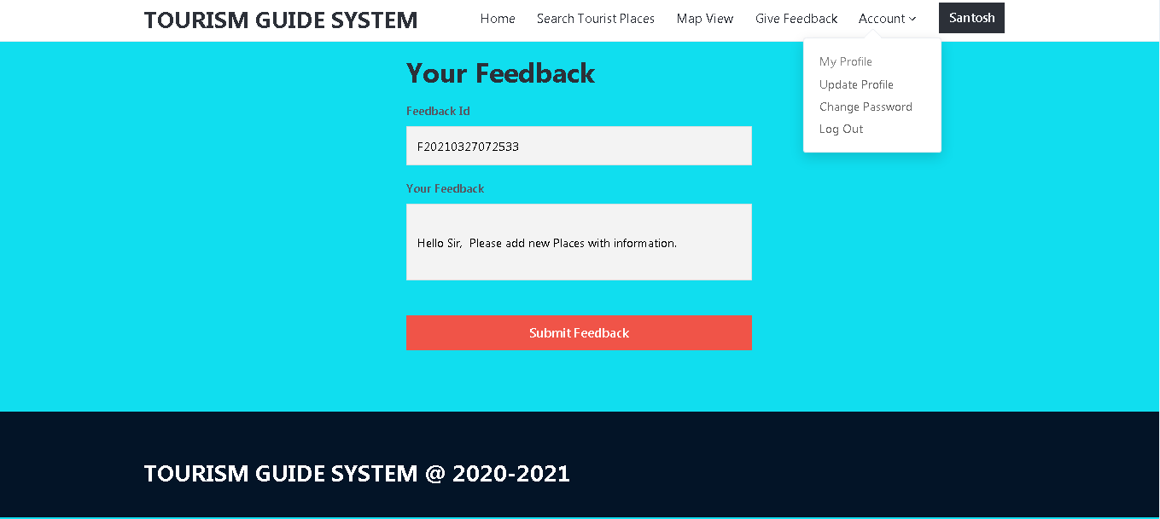

*My Profile. ( USER )*

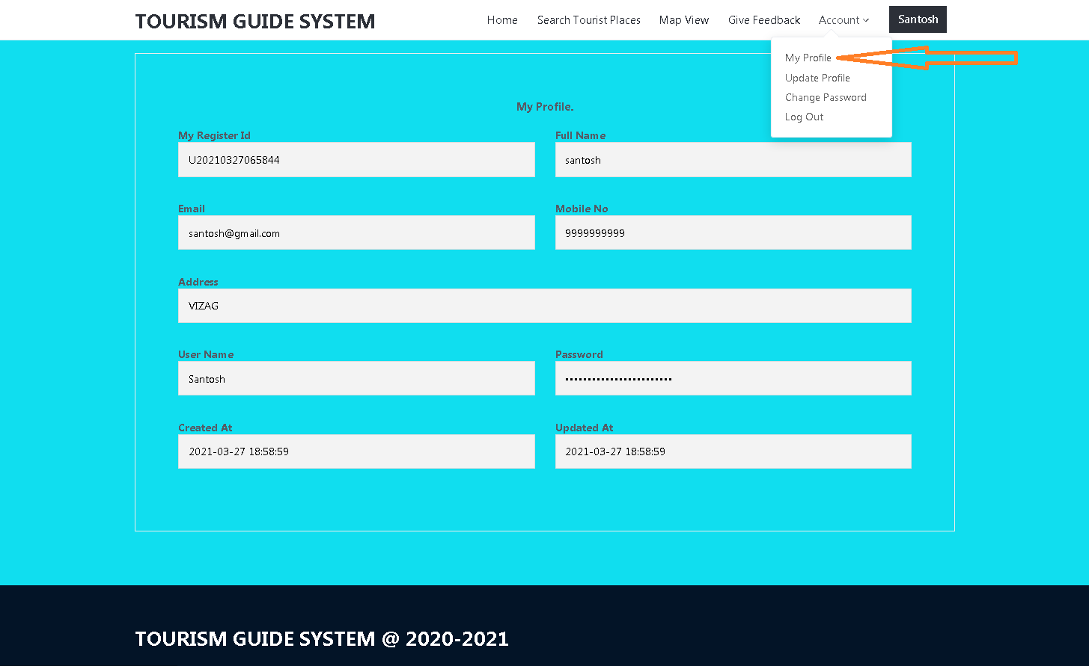

*Update Profile. ( USER )*

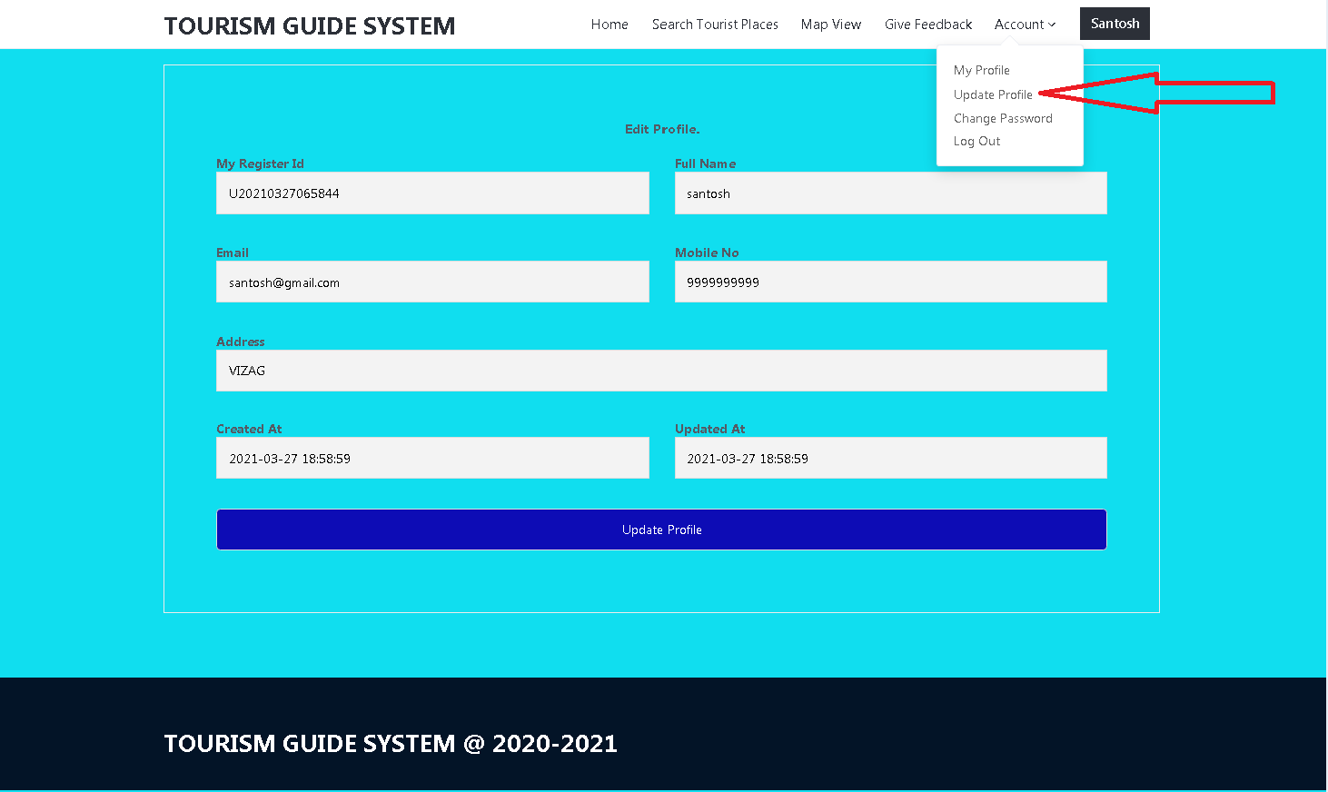

*Change Password. ( USER )*

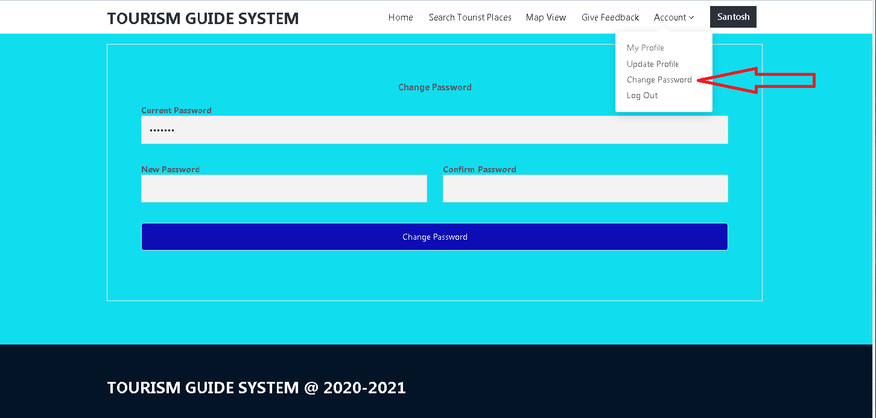

# Modules / Columns of Admin Profile in “TOURISM MANAGEMENT SYSTEM” Project :

## Main Module’s:

1. **Admin Login Page.**
2. **Admin Dashboard Page.**
3. **Add Tourist Places.**
4. **Tourist Places.**
5. **View Users.**
6. **User’s Feedback**
7. **User’s Questions and Answers.**

* **Sub module’s:**

1. **Change Password.**

*Admin Login Page.*

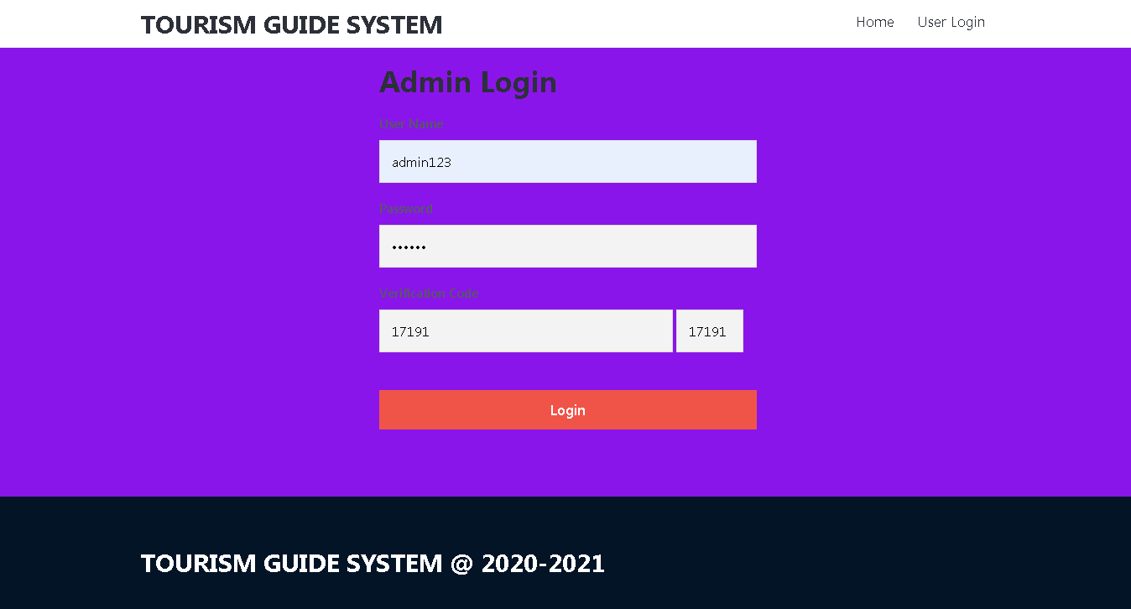

*Admin Dashboard Page.*



*Add Tourist Places. (ADMIN )*

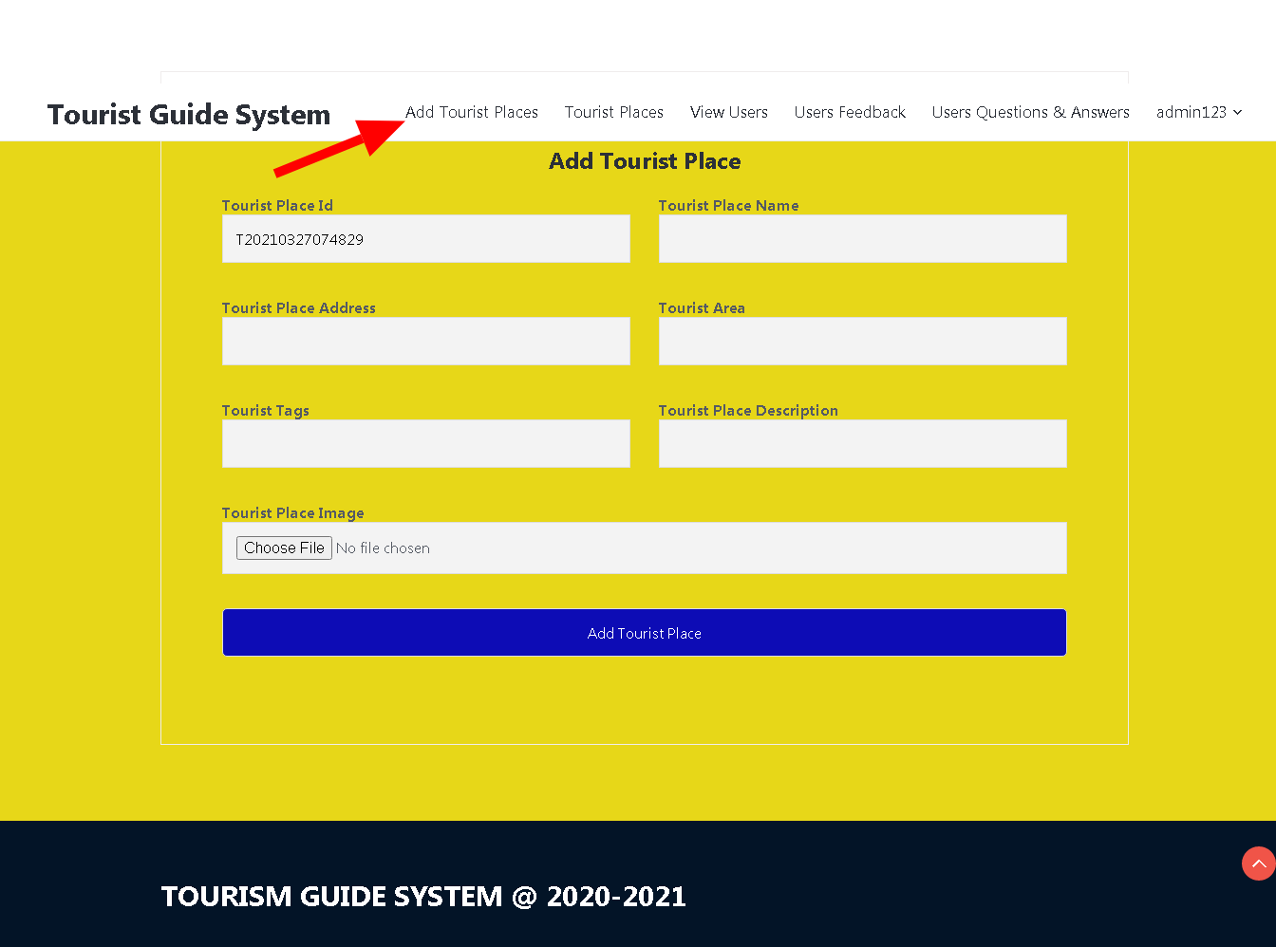

*Tourist Places. (ADMIN )*

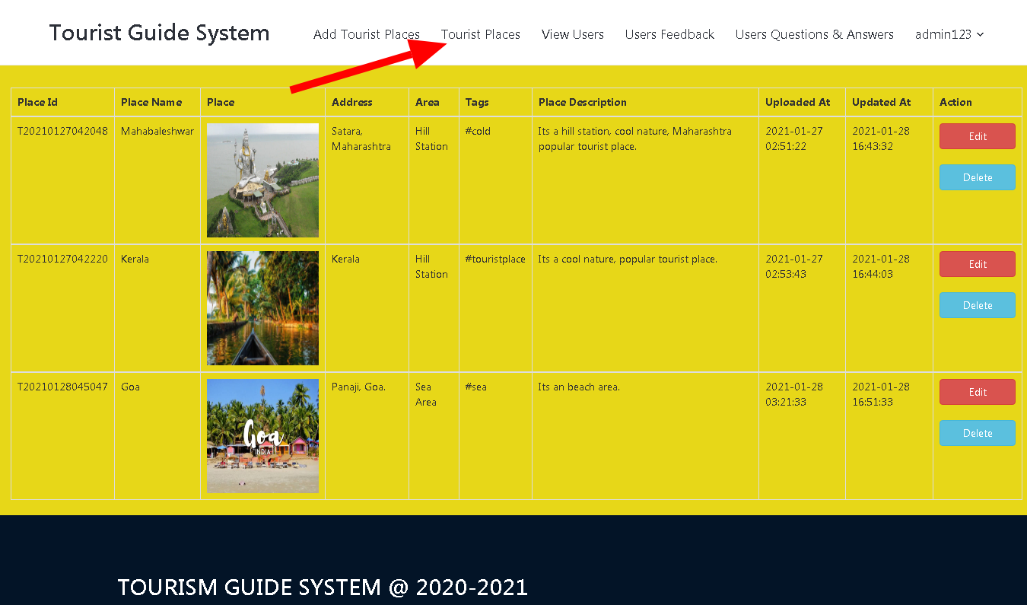

*View Users. (ADMIN )*

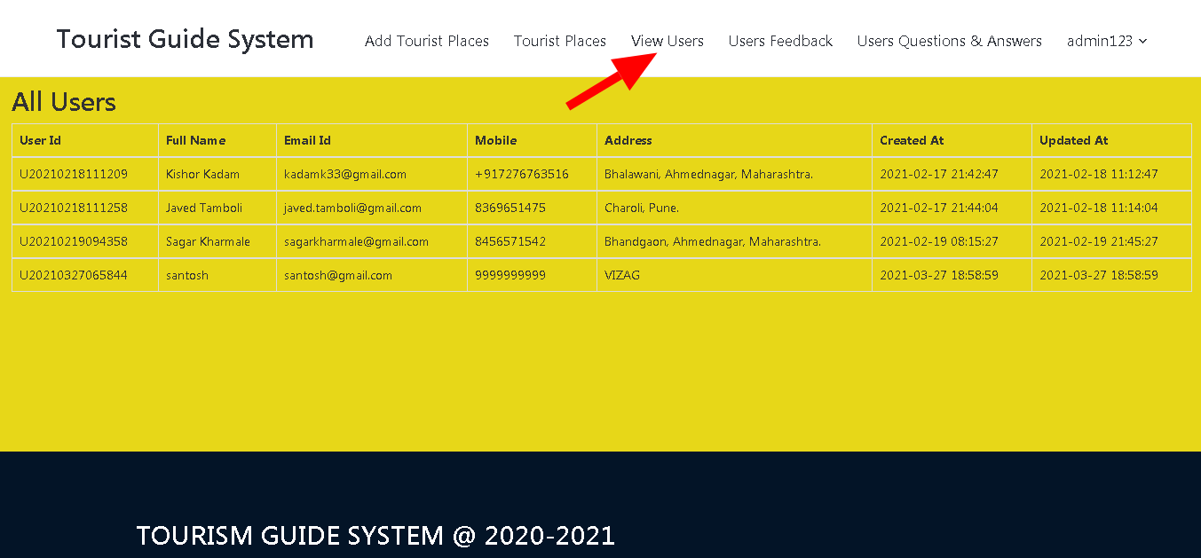

*User’s Feedback. (ADMIN )*

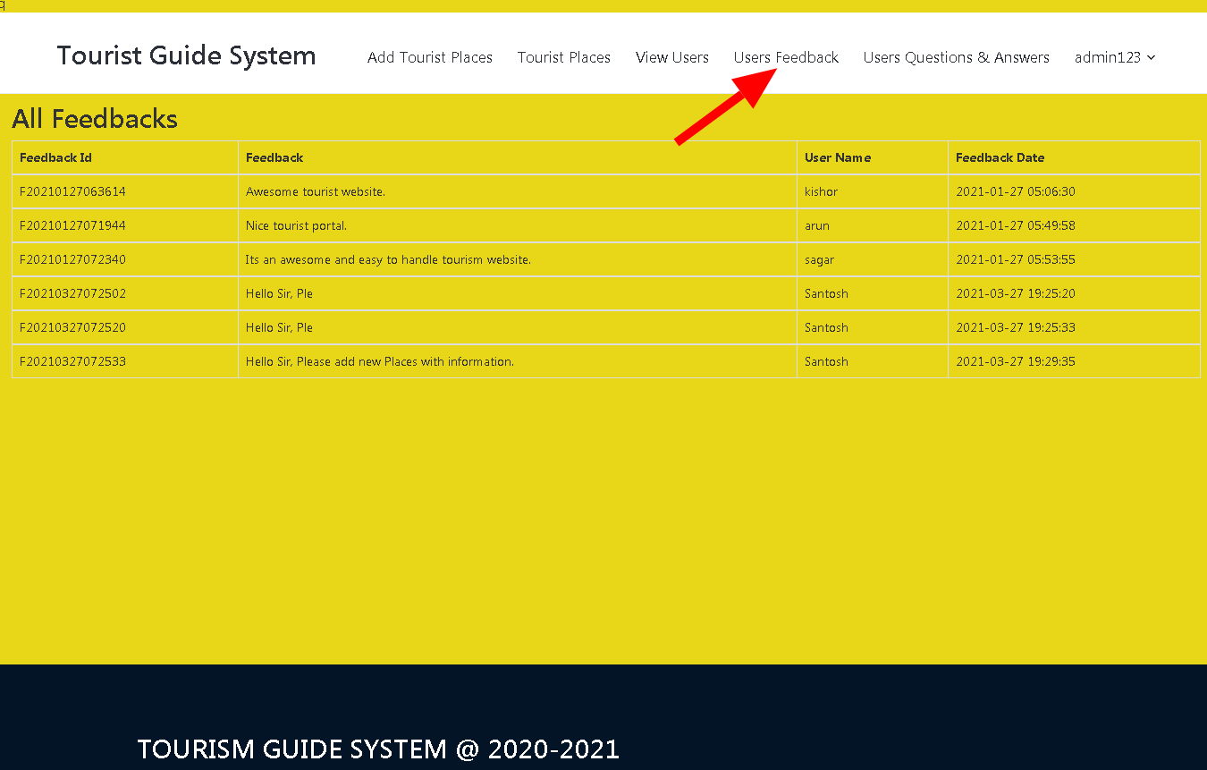

*User’s Questions and Answers. (ADMIN )*

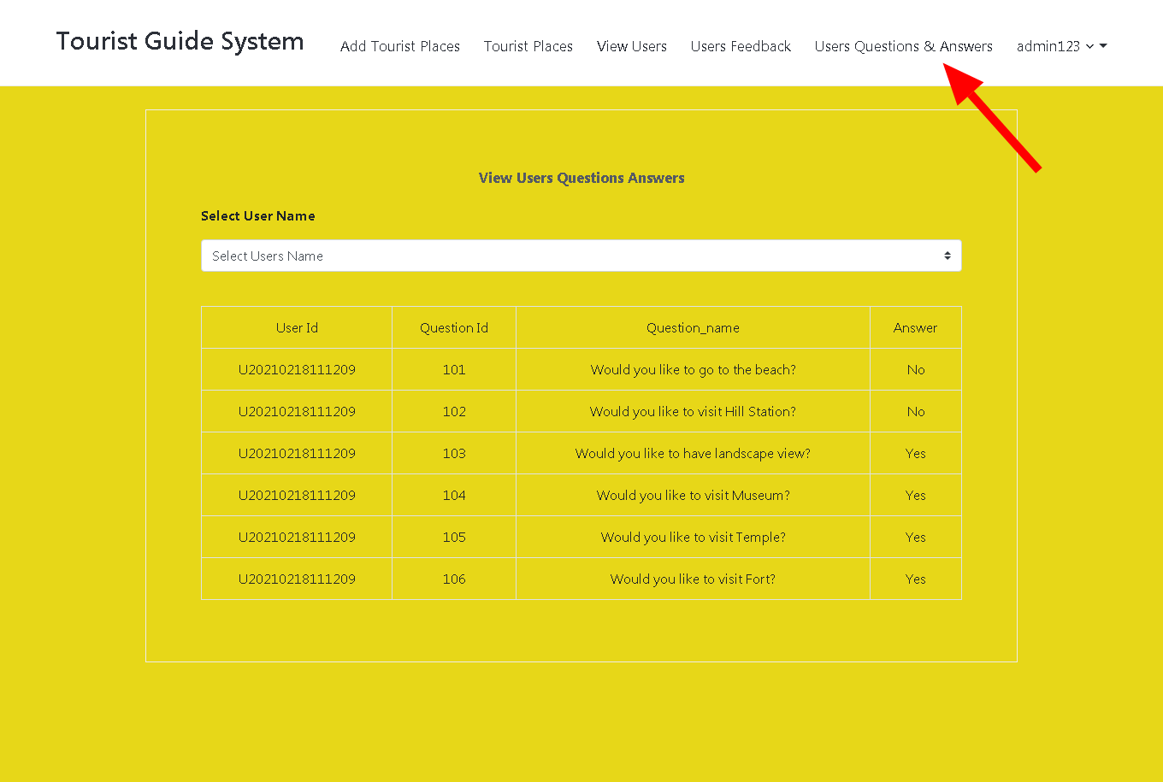

*Change Password. (ADMIN )*

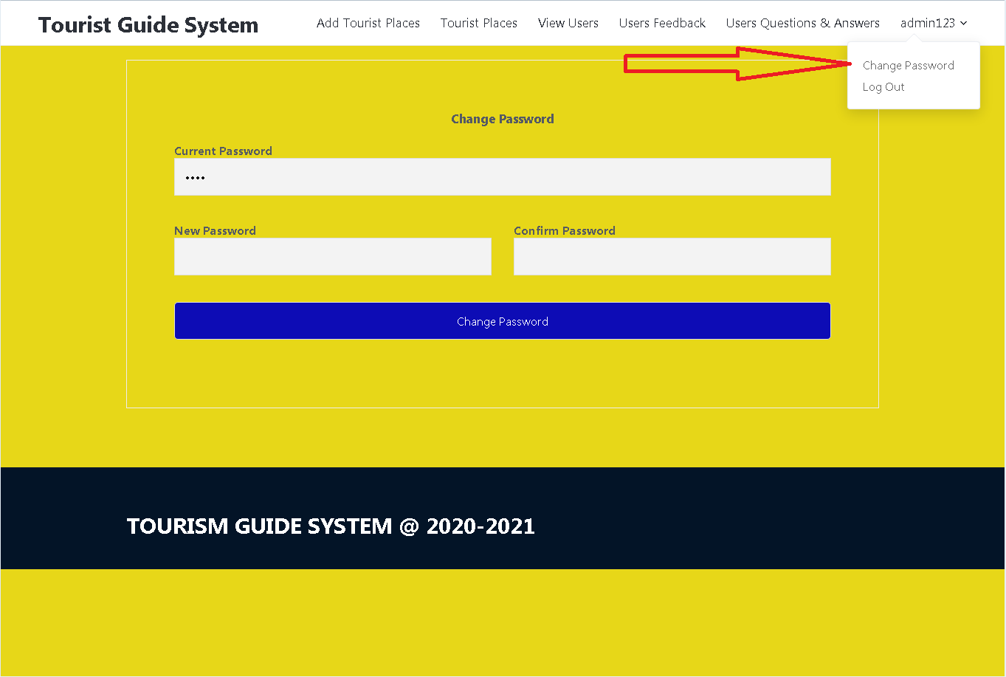

*Tourism Guide System SSSSSSSystem*

*Project has been*

*completed.*